4.4. PROJECT SNAPSHOTS

User’s Dashboard:

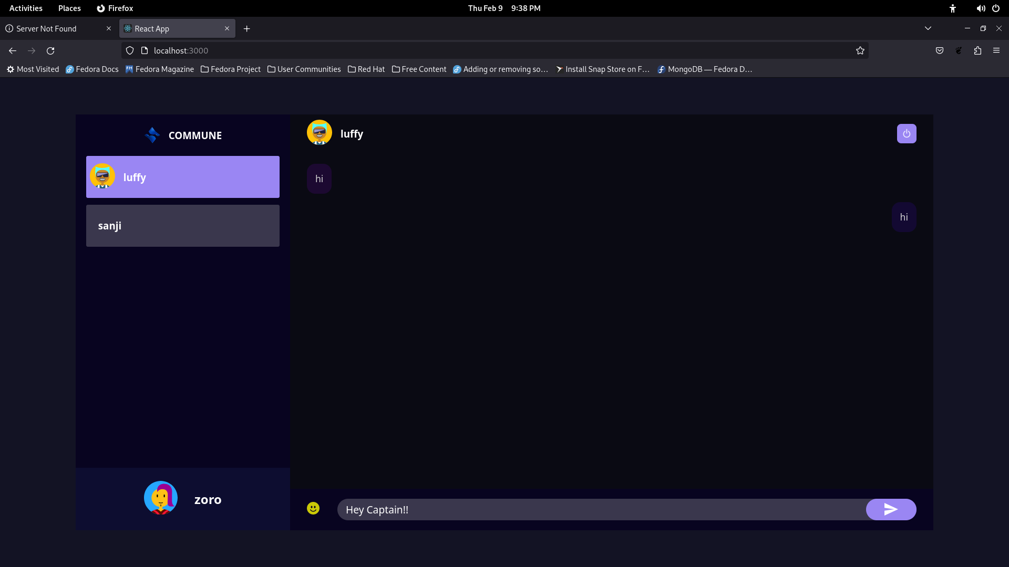

58
Login Page:

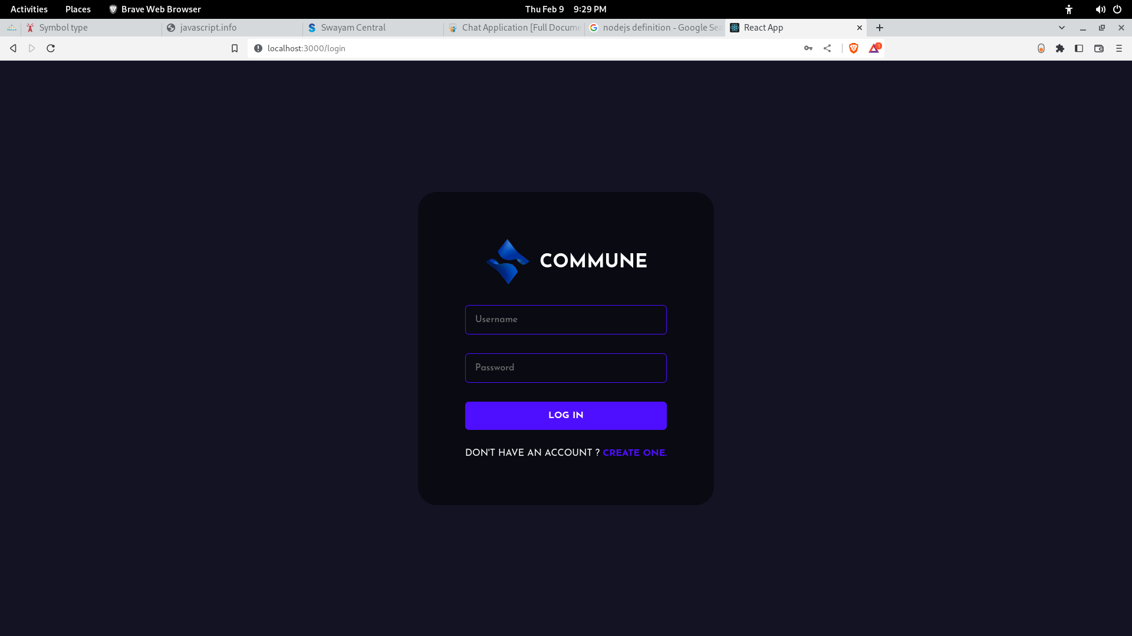

59
Register Page:

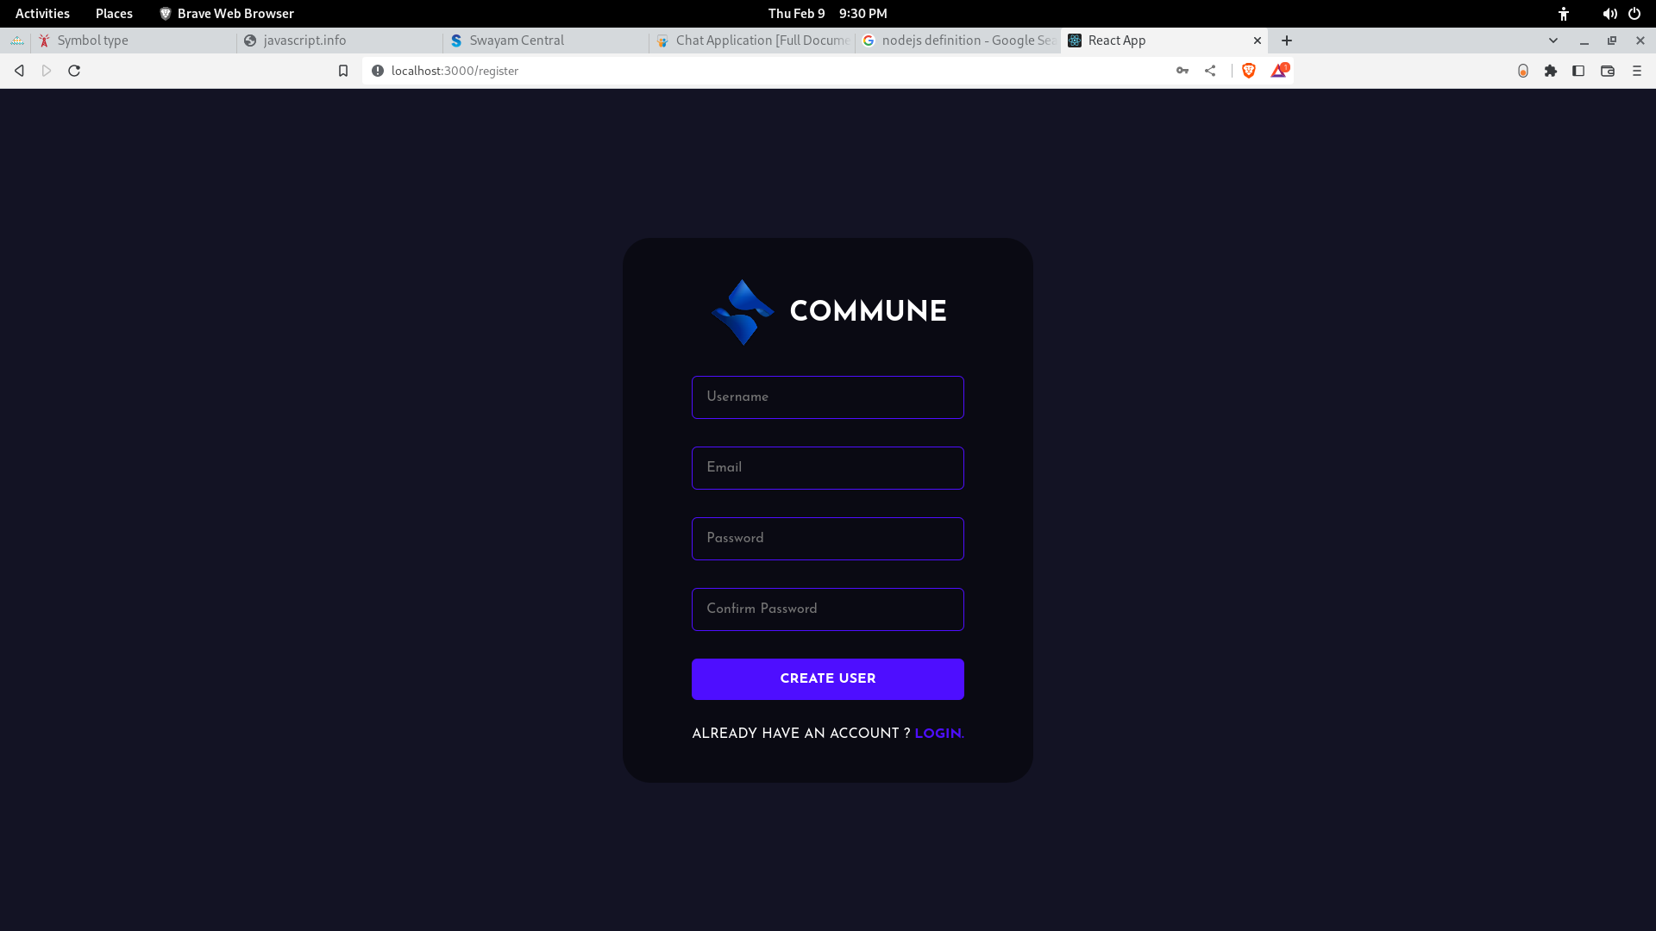

60

